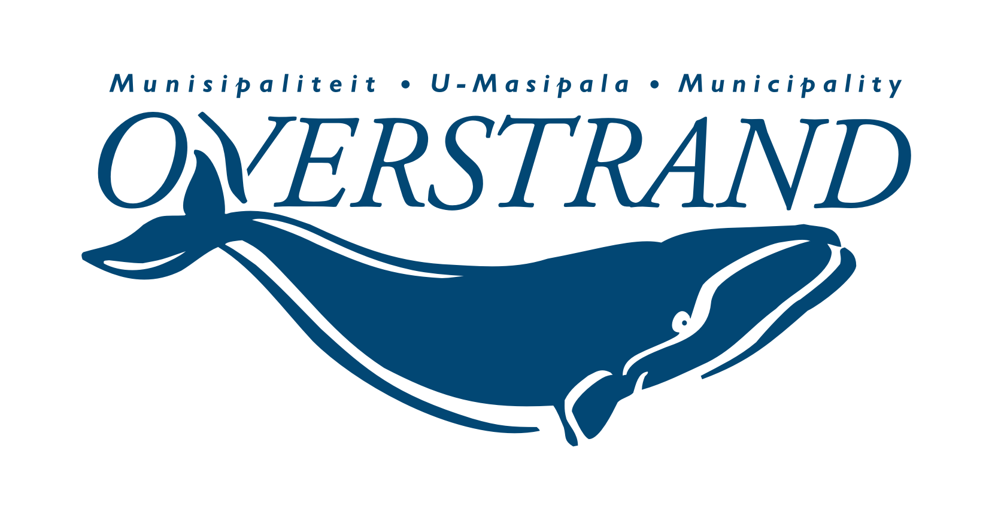
MEDIAVERKLARING / PRESS RELEASE
#Overstrand4all

ISSUED BY:
Municipal Manager: Dean O’Neill
Tel: 028 313 8003 | mm@overstrand.gov.za
Overstrand Municipality

MEDIA ENQUIRIES:
Riana Steenekamp
Tel: 028 313 8043 | rsteenekamp@overstrand.gov.za

EMBARGO: Immediate release
12 September 2022
Looking forward to a successful air layering propagation
The Hermanus Botanical Society are working with arborists in the Overberg on a project to propagate from trees in the botanical gardens at the entrance of the Fernkloof Nature Reserve, using a non-invasive air layering process.
Air layering is a method of propagating new trees and shrubs from stems still attached to the parent plant.
Hikers and people visiting the gardens, may notice little tin foil parcels hanging from some of the fruiting trees. The arborists are hopeful that in three months’ time, they will have grown a root ball so that the twig or small branch can then be transplanted and grown.
Successes will be shared with the stakeholders at the end of the process on a 50/50 basis. The new sprouts can be used in the Nursery or in the Garden.
Mary Ann Verster of the Hermanus Botanical Society said this project will be part of their work on the conservation and propagation of trees which is a significant target for accreditation of the Botanical Gardens.
A sign will be put up to ask people not to touch the tin foil parcels.
END/EINDE

